cond expressions

* simplify writing conditional expressions with more than 2 cases (parallel)
* multi-armed conditional
* any number of cases all at same level
* this is like switch statements

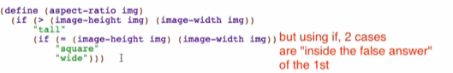

#;

* comments out the entire expression or definition that follows it

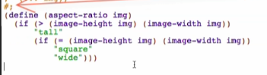

Re-do the aspect-ratio function

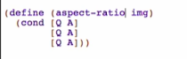

Q – question

A – answer

() and []

* both are equivalent (same treatment of racket) but by convention we use [] brackets around q/a pairs for cond so it will be easier to read

First question and answer

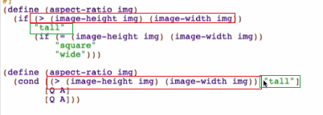

2nd case

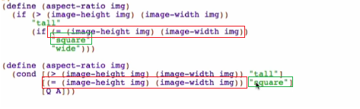

Last case

* in all other cases case
* question should be “else”

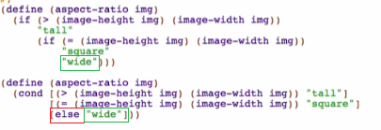

Overview:

